A000-Eur-England-Kent-Figurine-Flint-Paleolithic-Late Magdalenian-30 kya

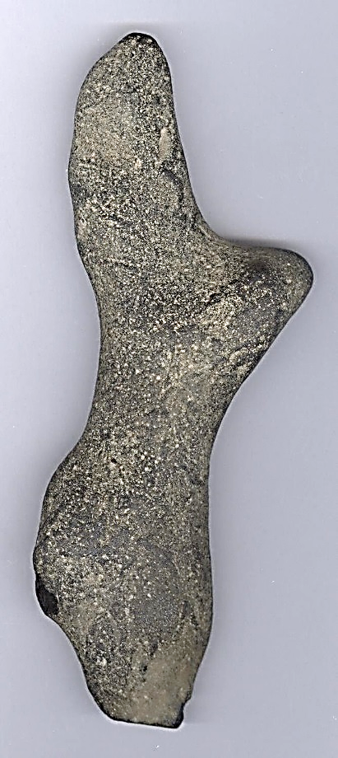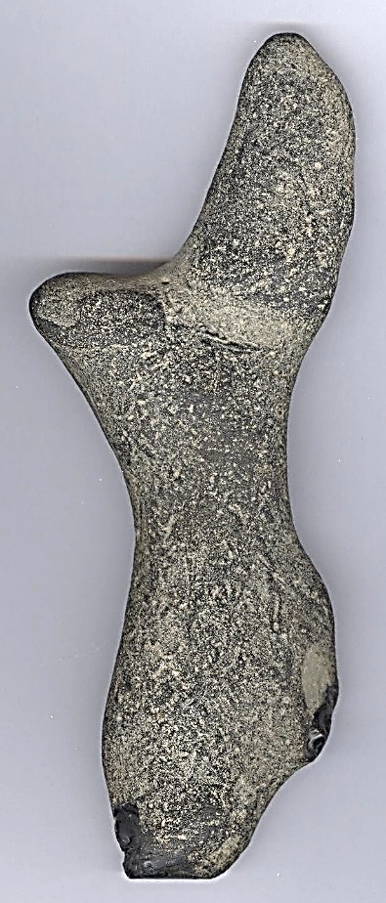

Fig. 1. Eur-England-Kent-Figurine-Flint-Paleolithic-Late Magdalenian-30 kya

**Formal Label:** Eur-England-Kent-Figurine-Flint-Paleolithic-Late Magdalenian-30 kya

**Display Description:** This figurine comes from near the destroyed flint quarries in Northfleet near Swanscombe and compares remarkably with similar Late Magdalenian flint quarry figurines from Courbet, France**.**

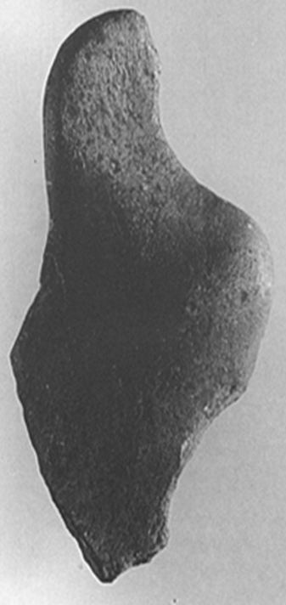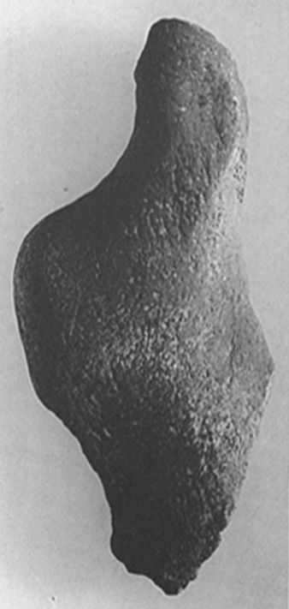

Fig. 2. Late Magdalenian Paleolithic figurine, Courbet, France. BM acc. No. 64.12.26.1168. From Sieveking 1987, plate 51:

**Accession Number:**

**LC Classification:** GN772.22.G7

**Date or Time Horizon:** Late Magdalenian

**Geographical Area:** Northfleet near Swanscombe, Kent

**Map, GPS Coordinates:** 0.33694, 51.441072; 51° 26' 27.859" N 0° 20' 12.984" E.

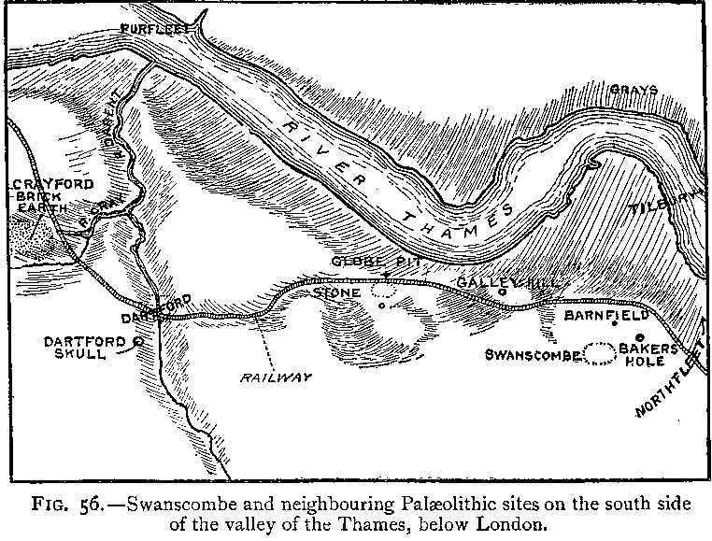

Fig.3. “Swanscombe and neighboring paleolithic sites on the south side of the valley of the Thames, below London,” after Keith 1916, Fig. 56.

Fig. 4. Map of Swanscombe and Northfleet on the south side of the valley of the Thames, below London, up to 1996, where Paleolithic peoples sought flint in the chalk outcrops and areas of quarries. After [LinguisticDemographer](https://en.wikipedia.org/wiki/User:LinguisticDemographer) at [English Wikipedia](https://en.wikipedia.org/wiki/).



**Cultural Affiliation:** Lower Paleolithic, Clactonian

**Medium:** Flint

**Dimensions: H 18 cm; W 11.5 cm.  
Weight:** 65.2  **gm, 2.29 oz**

**Provenance: Old English collection of flint artifacts from field walking Northfleet near the Swanscombe area.**

**Condition:** original with ancient patination.

**Discussion:** The BM has an apt description of their figurine from Courbet which ably expresses the value of the present one from Kent. “The present example is a pleasing illustration of the Palaeolithic artist’s ability to appreciate the potential in a natural shape. One break and a little chipping here were all that was required to produce a female figure” (Sieveking 1987:60). Similar outline shapes on incised petroglyphs are also found

**References:**

Conway, Bernard, John McNabb and Nick Ashton, eds.. 1996. *Excavations at Barnfield Pit,* *Swanscombe, 1968-72*; illustrations by Phil Dean. London: Dept. of Prehistoric and Romano-British Antiquities.

Glass, Helen. 2004. “Stone Age elephant remains found,” BBC News, 19 June. <http://news.bbc.co.uk/2/hi/uk_news/england/kent/3821527.stm>. Retrieved 1 Feb 2017.

Keith, Arthur. 1915. *The Antiquity of Man*. London.

Lisiecki, Lorraine E. and Maureen E. Raymo. 2005. “A Pliocene-Pleistocene stack of 57 globally distributed benthic δ18O records,” <http://www.lorraine-lisiecki.com/LR04_MISboundaries.txt>. Retrieved 1 Feb 2017.

## McNabb, John. 2007. *The British Lower Palaeolithic: stones in contention*. London, New York: Routledge.

# Schreve, Danielle C. 2009. “A new record of Pleistocene hippopotamus from River Severn terrace deposits, Gloucester, UK—palaeoenvironmental setting and stratigraphical significance,” *Proceedings of the Geologists' Association*, 120 (1): 58–64.

Sieveking, Ann. 1987. A Catalogue of Palaeolithic Art in the British Museum. London: British Museum

Stringer, Chris. 2006. Homo Britannicus: The incredible story of human life in Britain. London: Penguin.

Tester, P. J. 1984. “Clactonian Flints from Rickson's Pit, Swanscombe,” Archaeologia Cantiana, Kent Archaeological Society. Retrieved 1 Feb 2017.

Warren, S. H. 1922. “The Mesvinian Industry of Clacton-on-Sea,” Proceedings of the Prehistoric Society of East Anglia, 3: 597-602.

Additional Photographs

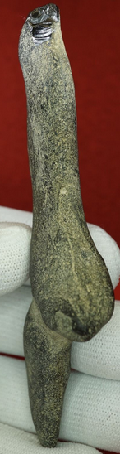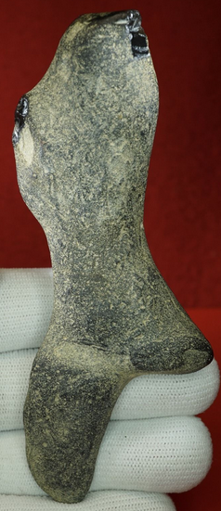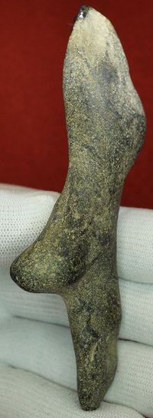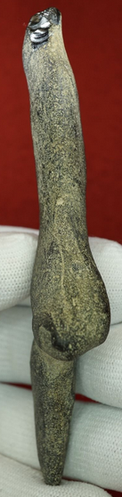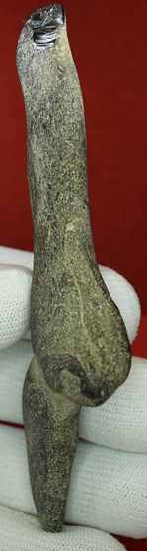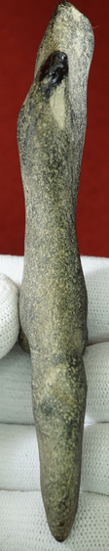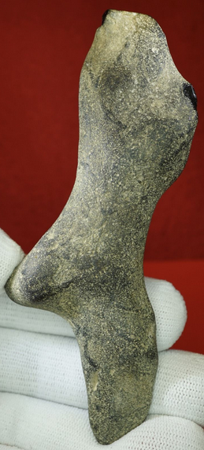

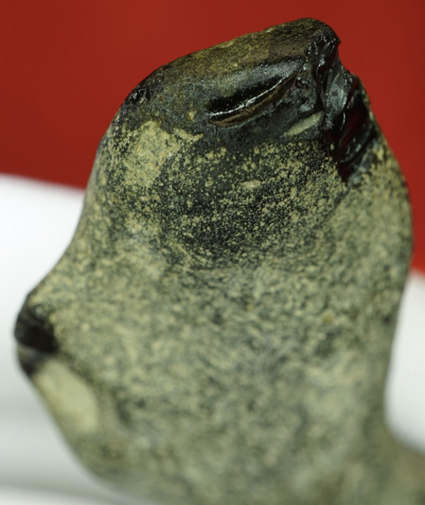 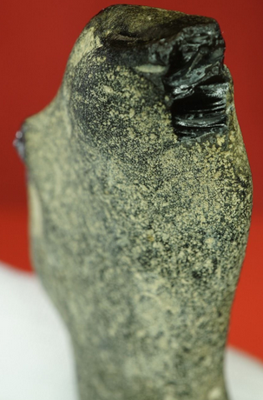

This Venus style figurine has been made on a naturally occurring flint nodule. It has undergone very simple working as the nodule already possessed the desired shape.

The head has burin like spall removals to create a pointed head (hood)

The pointed feet have been grazed, perhaps ground on a harder mineral.

The figure has a small bifacially worked area to the front chest area, possibly representing breasts?

Britain 14,000 years ago was still a peninsular of Continental Europe, migrating animals were probably followed and hunted by the nomadic peoples of Europe.

It is possible that these nomadic people rested in North Kent, perhaps to replenish their flint tool kits after following and hunting such animals as horse and reindeer.

While in the process of sourcing and making flint tools, they also came across these naturally occurring female looking flint nodules.

It is possible that these small portable flint nodules became a prized item for the hunter gatherers.

They were then taken back to their open air camps and rock shelters in the East.

These figure like nodules were then reproduced on workable material such as bone, antler, sandstone and jet, only Venuses found in Wylczse, Poland are also made on flint and are generally of plaquette types.

Here is a link with further information on the subject, the link is the fantastic dons maps website.

<http://donsmaps.com/couze.html>

c 15,000 years before present

Late Upper Palaeolithic, Magdalenian

Found Northfleet, Kent.

Height: 115 mm

Width: 16-31 mm

Thickness: 10 mm

Weight: 65.2 grams